The basket icon on the add to basket button, change to the same basket icon that we have in the top right corner of the reserve page | 
On the reserve page change this field to say Lola’s Rentals Siargao | 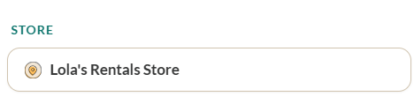
The inclusions list is the strongest conversion argument you have, and it's not at the booking page. Helmets, full tank, surf rack, damage protection, dry bag, first aid, discount card worth ₱5,000+ — this bundle obliterates every competitor on value. This needs to be visible at the point of booking, not just on the homepage.

Change this to 100, 500, 1000, 5000 | 
When the search has been made, the page should drop down to the available vehicles section automatically  The availability buttons where it says 28 available, perhaps make it so these buttons only show the availability when there are only 5 or less remaining?  perhaps add a scarcity nudge near date picker ("Our Vehicles fill up fast — secure yours now") | 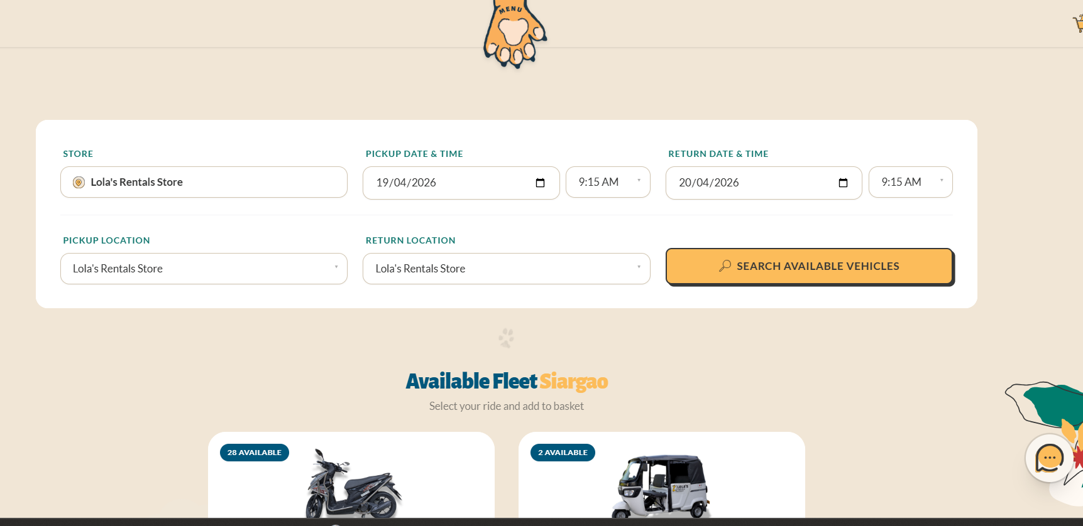
Reserves page it does feature the inclusions and the donation counter but it requires a lot of scrolling to find it. We need a way to make this more visiable.  also a comment like “book with us now, your booking funds animal welfare on Siargao” would work well. | 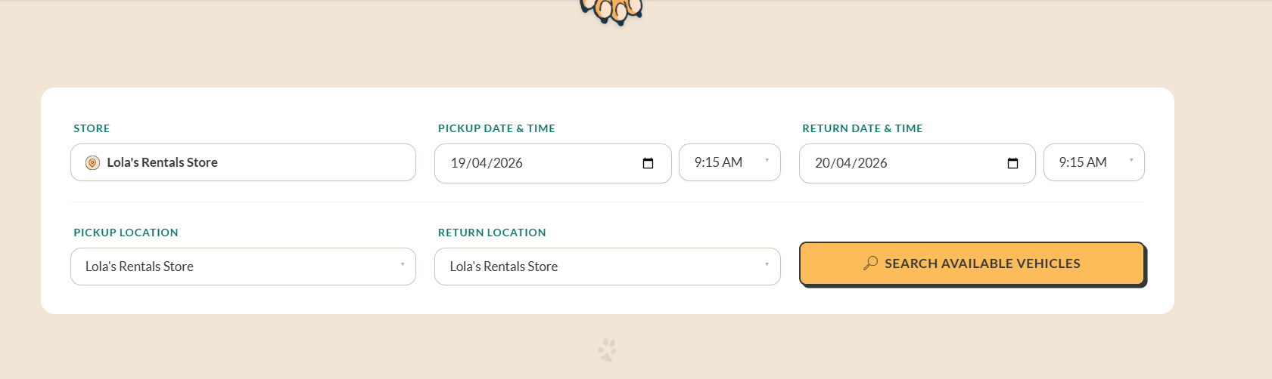
Learn more about be pawsitive link should have a space “Be Pawsitive” and when clicked, should open in a new window so the basket page stays there | 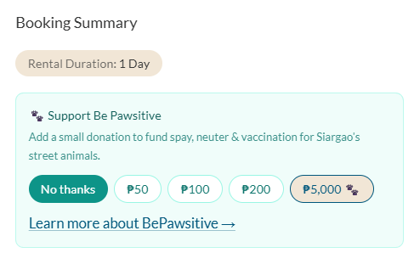
The international license section on the booking confirmed page should be moved into the bring your license section.  The size of this box can be reduced also |   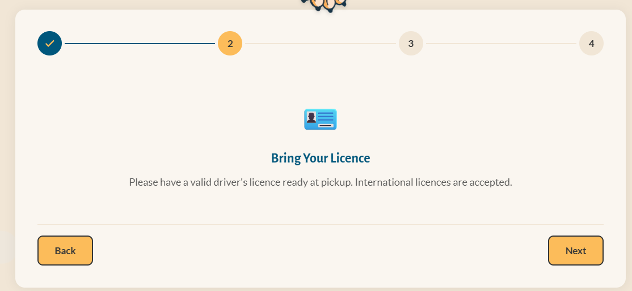
The complete your waiver button needs to be in sight once the booking is complete as many customers wont scroll down and we want them to see it and action it.

When I press this button the request fails (maybe I was too slow to press it?)
Use a different copy icon | 
I make an order via the customer facing website and the web quote info doesn’t populate | 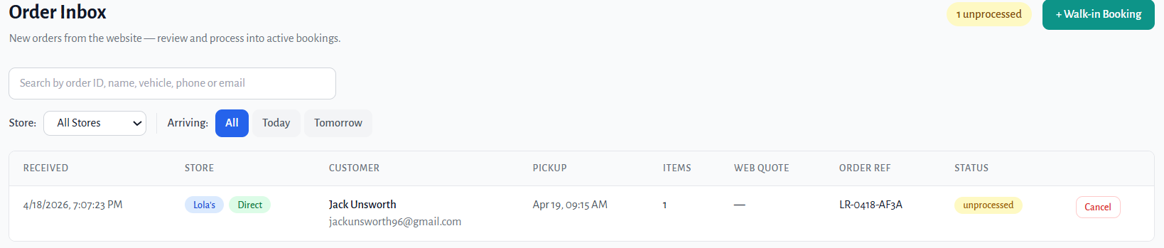
Backoffice transfers page, the value is 0, also doesn’t let me type the value either. So unable to collect payment | 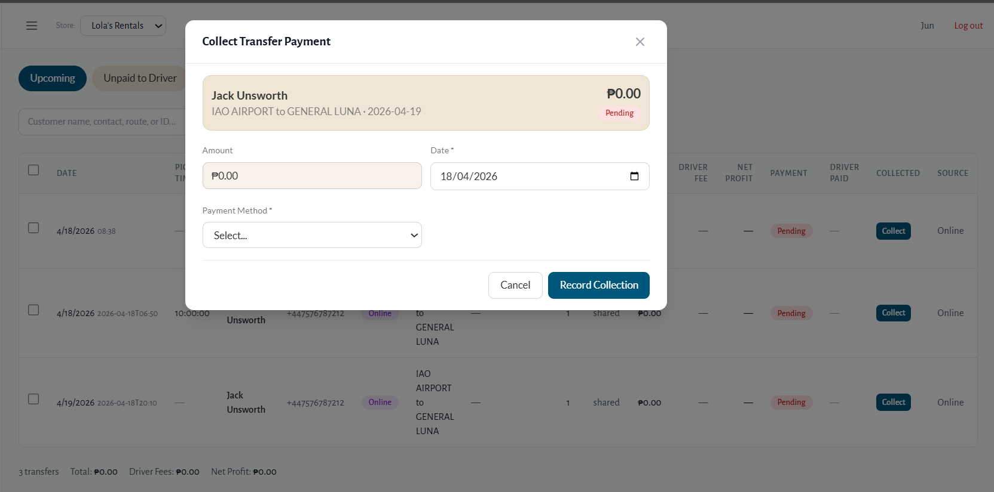
When the backoffice transfers pages loads, it briefly shows these empty kpi boxes and then they vanish | 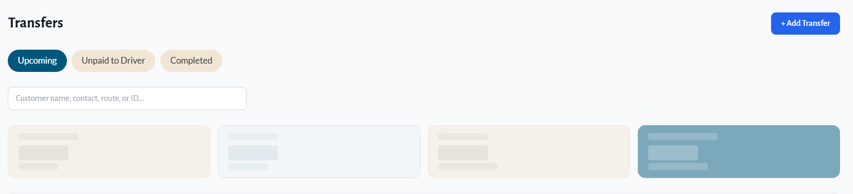
Extend rental page, the vehicle pic is too large and the box is also too big for the screen (on web) not sure about mobile/tablet | 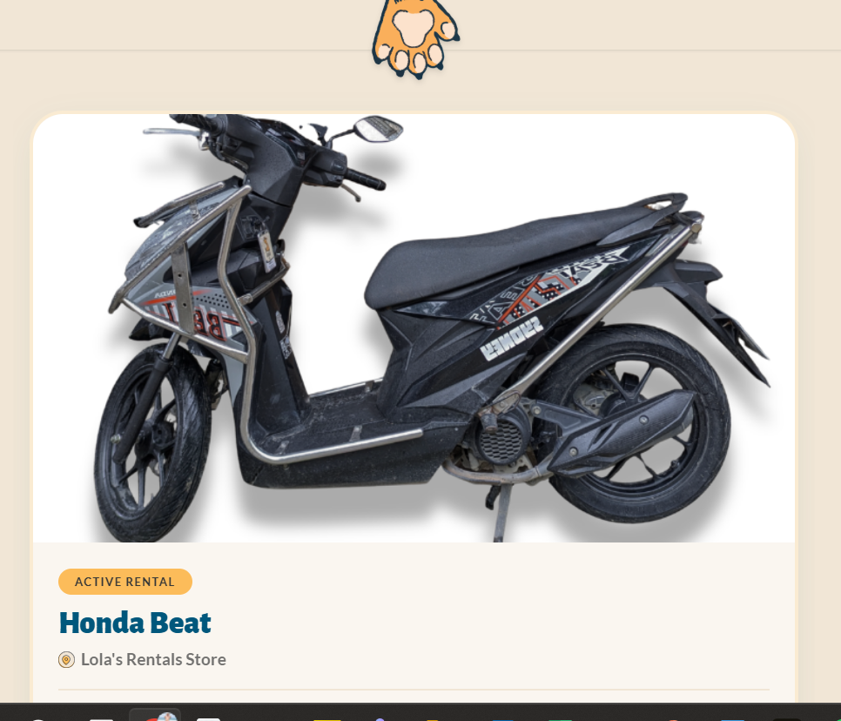
The extend calendar, if I click 21, it selects 20. If I select 22, it selects 21 (its not calibrated)  I also want the extend page to show their return time, not just the return date.  The pricing rules also still need to apply, example the booking is due for return on 20th 9:15am, if I pick 21st 9:15am its 1 day, if I pick 21st 9;45am onwards its 2 days.  it seems it actually computed 2 days, but only shows as 1. We also need to check whether this follows the pricing rules. Example maybe they originally rented 3 days (in our 3-6 day bracket) and then extend 1 day. They should be charged 1 day at the 3-6 day bracket not the 1-2 day bracket. This is perhaps a confusing workflow to build in that needs discussing.  the ” Extension confirmed? Your new return date will be updated. Please settle the balance due at return.” Change to ask them to come by our store to settle the outstanding payment. | 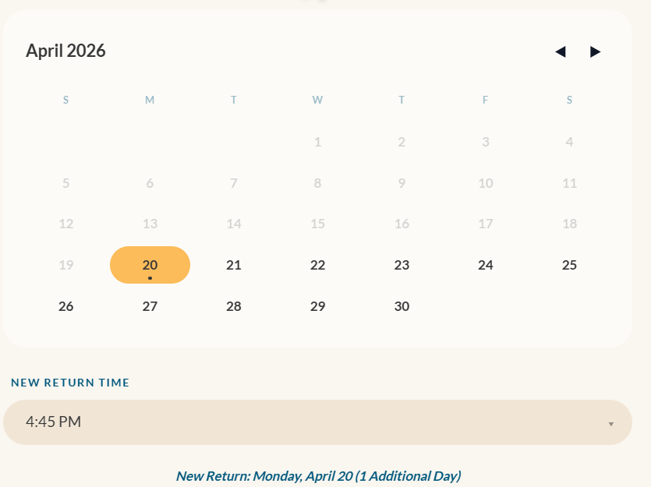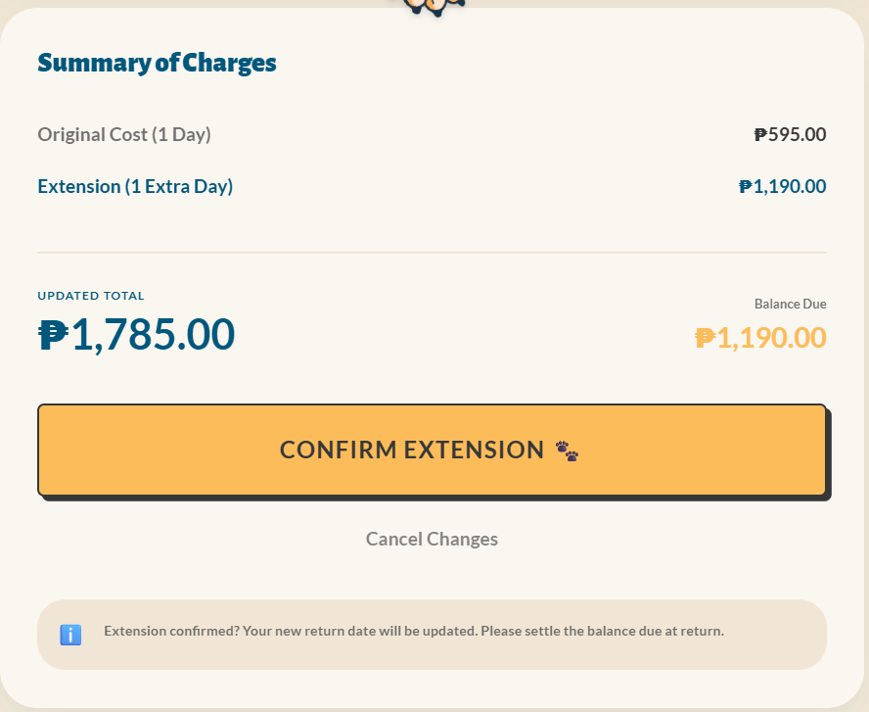
Change the lola icon to the same as the booking confirmed page | 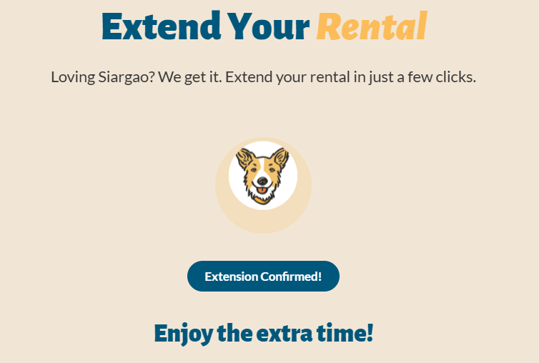
The extension page, is 1000 more than what was stated before, I think it has added another deposit. We already have the deposit from the first time we do not collect another. The incorrect value is also shown on the extend email and the return time stated is also very wrong.  the new return-date on the image to the right should also show the time, not just the date. | 
The extension is not shown on the backoffice, the date remains the same, no sign or needing to collect extra payment, can we check the code. It is possible because I have extended a booking that is still in the inbox and not an active order? If this is the case should it be allowed the customers whose rentals have not yet started can extend? Maybe this needed fixing.
Home page, the right flower is cut off at the bottom by the divider. Overlay the floral design so this doesn’t happen | 

